Carmel Valley Preschool Lesson Plan
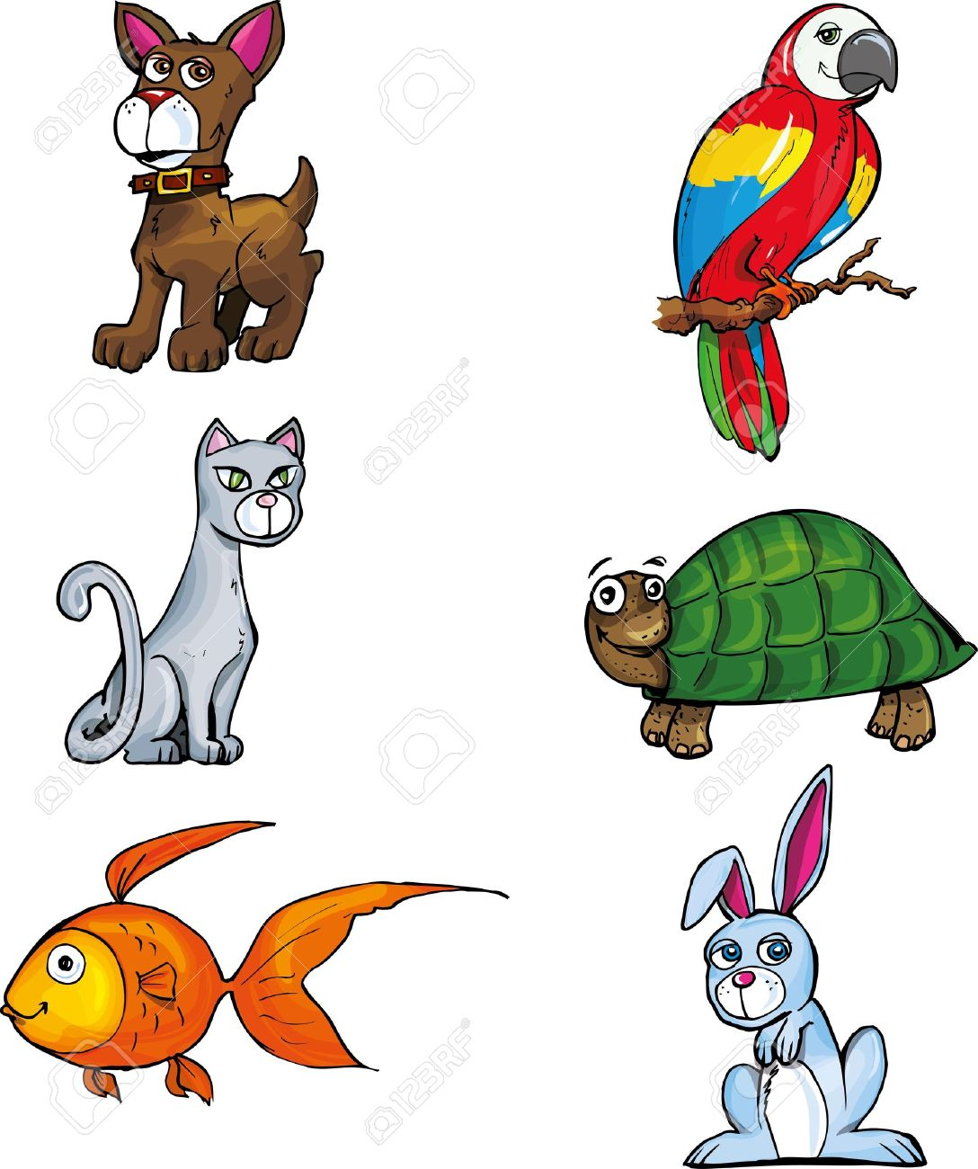
Teacher: Ms. Trez

Date: September 21st -25th
Christian Value Lesson: God Made The Animals
Readiness: Shape: Square; Color: Red
Theme: Pets II
 | Monday | Tuesday | Wednesday | Thursday | Friday
Circle Time | Morning  Round-up  *The pout-  pout fish  -story- | Morning  Round-up  *The pout-  pout fish  -story- | Morning  Round-up  *Early bird  -story | Morning  Round-up  *Early bird  -story | Morning  Round-up  *Name that  pet…  -flannel-
Art | Our pet  fish | Our pet  fish | Our pet  bird | Our pet  bird | Our pets  rabbit & mouse
Music/  Movement/  Large Motor | We’re  going to the  pet store…  -song- | We’re  going to the  pet store…  -song- | We’re  going to the  pet store…  -song- | We’re  going to the  pet store…  -song- | We’re  going to the  pet store…  -song-
Math/  Science/  Readiness/  Fine Motor | Matching  Pets  -folder game- | Matching  Pets  -folder game- | Matching  Pets  -folder game- | Letters  A, B, C & D  review  -readiness- | Letters  A, B, C & D  review  -readiness-
REMINDER/SPECIAL ACTIVITY: So exciting to say that our 1st chapel of the school year will be scheduled for this Friday September 25th.

