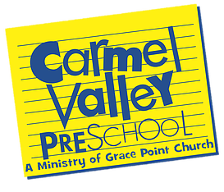
LESSON PLAN
Theme: Let it Fall
Language Arts: Fall Colors, writing, sight words & Math
Christian Value:Book of Exodus

 | MON 9/21 | TUES 9/22 | WED 9/23 | THUR 9/24 | FRI. 9/25
Remote Learning

Art Projects | Color the leaves | Open Art | Water color painting | Open Art | Painting with fall colors
Music | The Learning ctr. | The Learning Ctr | The Learning Ctr. | The Learning Ctr | Biblical music
Math/  Science or  Language Arts | Sequence  Autumn colors | Read: On the Farm | Fall weather activies | Read: Pumpkin countdown | Letter Review  Fall leaves
Christian Value Lesson | Book of Exodus | Book of Exodus | Book of Exodus | Book of Exodus | Bible review
Outdoors | Recess | Recess | Recess | Recess | Recess

Teacher: Ms. Renee
Date: 9/21-25 2020

